Exercises about users and groups management :

1) Add two new groups named “daw” and “crey”
First, remember to start a sudo su session because we will need administrator privileges to run the commands and get done the tasks, we have already opened the sudo su session, so to create the new two groups you will need the command “groupadd” plus the name of the group, we can use too addgroup, so run the command: addgroup “daw” and addgroup “crey” plus enter, then run the command: cat /etc/group plus enter to show the groups just created:
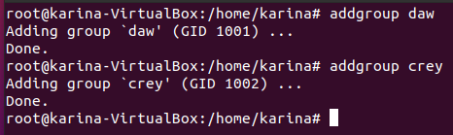

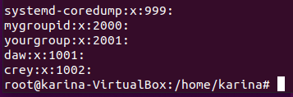

2. Change “daw” and “crey” GIDS to 2001 and 2002, respectively.
We are going to use the command groupmod with the option -g, like this: groupmod -g 2001 daw:

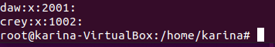

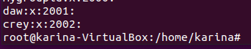

3. Create a new group called “profesores” with GID of 2003. Then, modify the group name to teachers: To create the new group you will use again the command groupadd -g x(the gid) and name; then the command groupmod -n (new name) for change the name of the group:
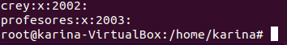

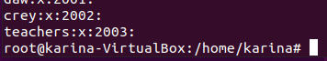

4. Verify that you have correctly created the groups named “daw”, “crey” and “teachers”
With the command cat etcgroup we can check the groups just created:

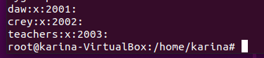

5. Add a new user named “john” whose primary group is “crey”.
We going to use the command: useradd -g crey john: tenemos que añadir -m “useradd -g crey -m john, para el home directory es

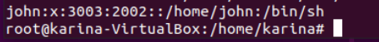

Has the home directory been created with the default command? The answer is not, because we have not indicated in our command and the system confirms this.

6. Add a new user named “mary”, whose primary group is “daw” and the home directory /home/mary:
The command will be: adduser mary -g daw -d home /mary, then with the command cat /etc /passwd you can see the new user

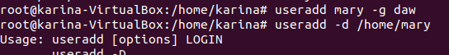

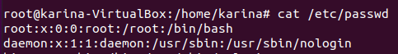

7. Add a new user named “martha”, whose primary group is “teachers”, the home directory
/home/martha and belonging to the secondary group “crey”

With the command adduser -m -g teachers -G crey Martha:

8. Add the following names to the users that you have just created:
a. John= “John Doe”
b. Mary = “Mary Williams”
c. Martha = “Martha Jones”

We are going to use the command usermod -c “new user´s name” current user´s name and then as usual cat/etc/passwd:

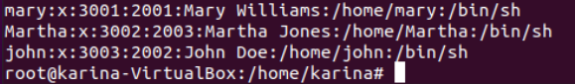

9. How could you check that you have created all the users with the right primary groups?
With the command cat /etc/group | grep daw, cat /etc/group | grep crey y cat /etc/group | grep teachers:

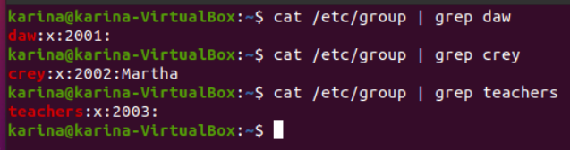

10. Verify if crey and daw groups have martha as a member:
With the command id -Gn Martha we can check the groups (sorry, I could not do it with the ones in the manual), Martha is not in Daw because we did not assigned that group:

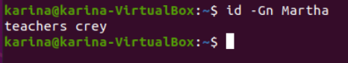

11. Can you log in with any of the users you have created?


Not yet because we have not assigned the passwords.

12. Set the password “martha22” for the user “martha”
We assigned the password with the command: passwd Martha:

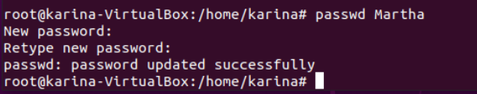

13. Display on the shell prompt the groups to which Martha belongs:
We can use the any of the following commands: id Martha or id -Gn Martha or groups Martha;
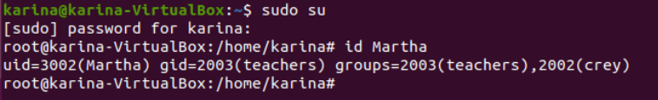

14. Create a directory named “teachers” in “/home”. Then, assign the directory “/home/teachers” to the user martha (you can do all the steps typing just one command).

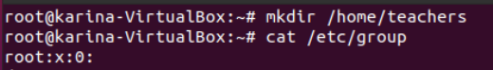

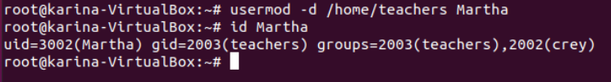

15. Now, log in as user “martha”. Run the command “cd $HOME” and check that the home directory is “/home/teachers”

I could not login with Martha,

16. Go back to the root shell

17. Change the shell of the user named “john” to “sh”:
First we have to check the current user,s shel with the command: grep john /etc/passwd; as we can see, the user already belongs to sh shell, so we are going to change it for bash with the command: usermod -s /bin/bash john:

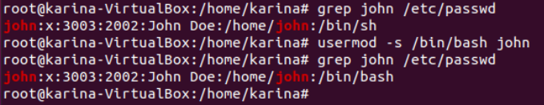
18. Add the user “martha” to the secondary group “daw” without removing the already assigned
secondary groups.

19. Run a command to print the following information for each user
User Primary group Secondary groups
john crey
mary daw
martha teachers crey, daw

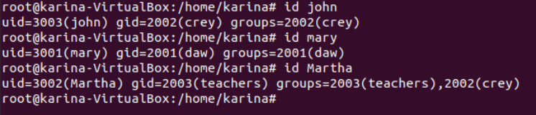
20. Delete all the groups you have created. Could you delete them? Why?
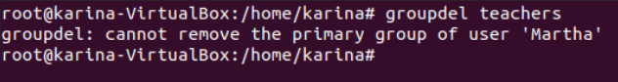
Because the groups are not empty, there are users, so we have to delete first the users.

21. Delete all the users you have created, including the files and directories inside the home.

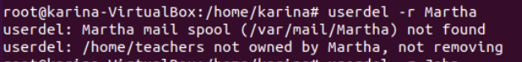

22. Try again to delete the groups

